Name : Ganesh G

Subject: Java Internship (25 Sep 2023 – 25 Oct 2023)

Phone : +91 8095912681

Email : [ganeshg2k3@gmail.com](mailto:ganeshg2k3@gmail.com)

**Week - 2 Internship Task**

**MOTIONCUT**

During the second week of my internship, I was tasked with creating a Java program for a temperature converter.

Introduction :

I have implemented a Java program for temperature conversion, encompassing conversions from Celsius to Fahrenheit and Fahrenheit to Celsius. This program effectively gathers user input and produces precise results.

Program :

import java.util.Scanner;

public class TemperatureConverter {

public static void main(String[] args) {

Scanner scanner = new Scanner(System.in);

System.out.println("Temperature Converter!");

while (true) {

System.out.println("Please select an option:");

System.out.println("1. Celsius to Fahrenheit");

System.out.println("2. Fahrenheit to Celsius");

System.out.println("3. Exit");

int option = scanner.nextInt();

if (option == 1) {

convertCelsiusToFahrenheit(scanner);

} else if (option == 2) {

convertFahrenheitToCelsius(scanner);

} else if (option == 3) {

break; // Exit the program

} else {

System.out.println("Invalid option. Please select 1, 2, or 3.");

}

}

scanner.close();

System.out.println("Thank you for using the Temperature Converter!");

}

private static void convertCelsiusToFahrenheit(Scanner scanner) {

System.out.println("Enter the temperature in Celsius:");

double celsius = scanner.nextDouble();

double fahrenheit = (celsius * 9/5) + 32;

System.out.println("Temperature in Fahrenheit: " + fahrenheit);

askForAnotherConversion(scanner);

}

private static void convertFahrenheitToCelsius(Scanner scanner) {

System.out.println("Enter the temperature in Fahrenheit:");

double fahrenheit = scanner.nextDouble();

double celsius = (fahrenheit - 32) * 5/9;

System.out.println("Temperature in Celsius: " + celsius);

askForAnotherConversion(scanner);

}

private static void askForAnotherConversion(Scanner scanner) {

System.out.println("Do you want to perform another conversion? (y/n)");

String response = scanner.next().toLowerCase();

if (response.equals("n")) {

System.out.println("Thank you for using the Temperature Converter!");

System.exit(0);

}

}

}

Sample Output :

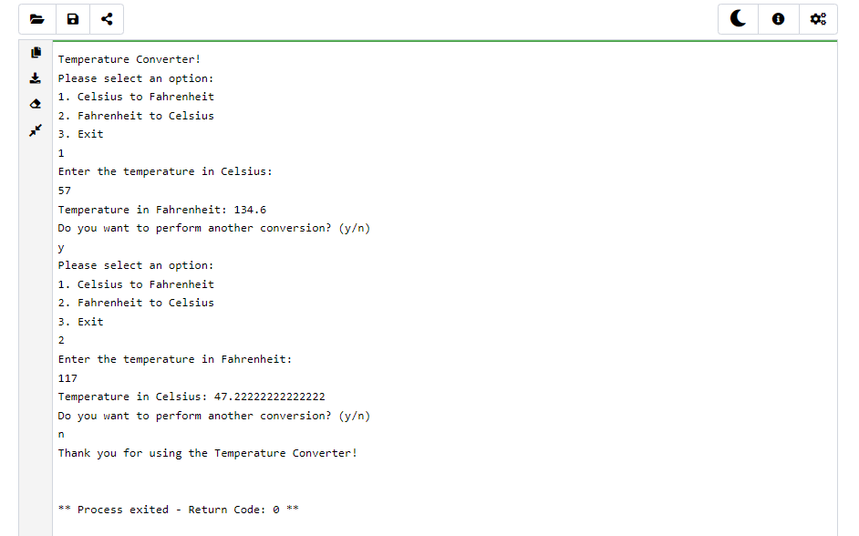

Conclusion :

My Java program for temperature conversion adeptly handles both Celsius to Fahrenheit and Fahrenheit to Celsius conversions, ensuring accurate results while taking user input into account.